Campaign Name: | “Don’t Wreck Your Text” | 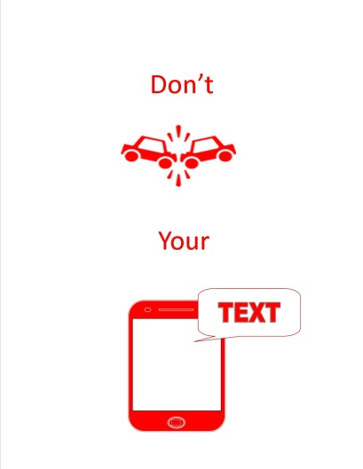
Type of campaign: | Raising awareness to teen drivers about vehicle safety and dangers of texting and driving
Purpose: | This campaign was designed to catch the attention of young drivers and the dangers of texting and driving in your own school community. | Enclosed inside are:  - Sample Timeline  - Logo  - Fact Sheet  - Activities  - Power Point  - News Release
“Don’t Wreck Your Text” Campaign Fact Sheet

